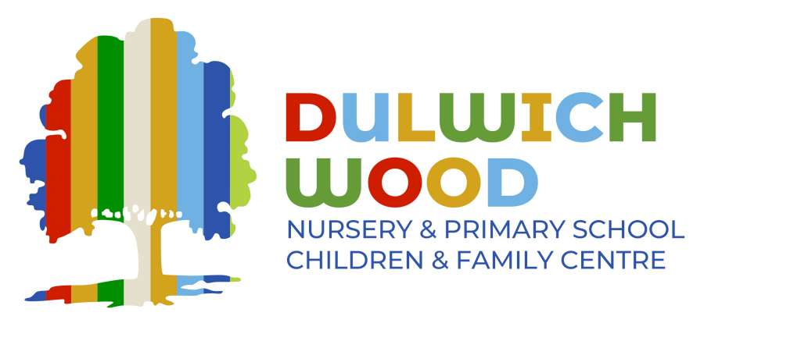

**Early Years Educator**

Dulwich Wood Nursery is looking for talented and motivated Early Years Educator to join our team and become a key person to a group of fantastic three and four year olds.

Dulwich Wood Nursery is a happy, friendly place serving a diverse, multicultural community. If you join our team you will be well supported through professional development and have the chance to work with wonderful children and a dedicated staff.

We have amazing outdoor learning spaces and are passionate about outdoor learning so you must have a pair of wellies and be prepared to work outside with children in in the gardens and our local woods.

We are committed to a play-based child-centred approach to learning. Our planning is adapted ‘in the moment’ in response to children’s explorations and fascinations.

Our school is a 2-minute walk from Sydenham Hill train station and just 15 minutes’ walk from Gipsy Hill station.

We are looking for someone who:

* Is creative, patient, resourceful, energetic and adaptable
* Has experience of working with children (ideally in a nursery or primary school)
* Has a level 3 childcare qualification or equivalent qualification
* Has GCSE English and Maths (Grade C+) or equivalent
* Is keen to develop professionally and learn with and from others
* Has good ICT skills and written communication skills
* Is a resilient, positive person with a ‘can-do’ attitude

This post is a ‘term time only’ contract. Working hours: 36 per week.

The salary for this position i**s Grade 7 SCP 4 –9.**

This post will be a 1-year contract in the first instance.

If you would like to find out more about the role and see our fantastic Early Years provision please call 0207 525 1192 to arrange a visit with our Nursery Leader, Lindsey Wales.

Closing date: Monday 2nd December 2024

Interview date: Wednesday 4th December 2024

Start date: Monday 6th January 2025

Dulwich Wood Nursery School is committed to safeguarding and promoting the welfare of children and young people and expects all staff and volunteers to share this commitment. We will ensure that all our recruitment and selection practices reflect this. The successful candidate will be subject to Disclosure and Barring Service checks along with other relevant employment checks.