**Now I Am 2**

**Drop-in**

**Bring your 2 year old along to our new drop-in group**

**We offer a structured group delivered by our Early Years Team which will incorporate elements of a group education setting.**

**We can advise you on all aspects of school readiness and the application process while your little one plays.**

**Tuesdays during term time.**

**1.30 - 3.00pm**

**Dulwich Wood Children’s Centre, Lyall Avenue, SE21 8QS**

**Call 0207 525 2017 for more info**

**I am……**

**Ready to Make**

**Friends**

**Getting Ready for Nursery**

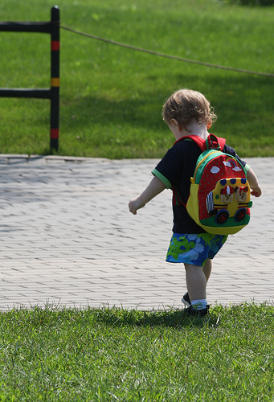

**Learning to make choices**