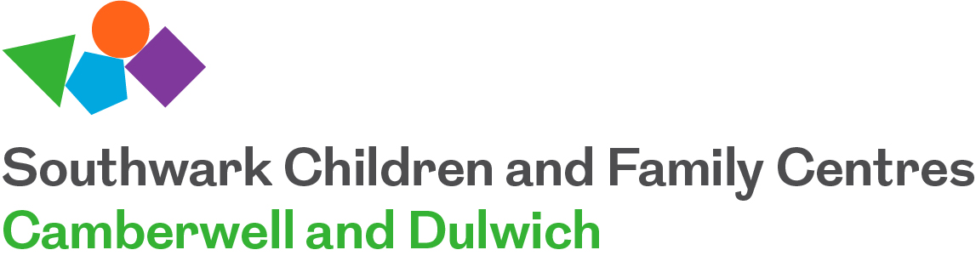

Camberwell and Dulwich Children’s and Family Centres
Fixed Term November 2019 – March 2020
Community Family Worker

We are currently recruiting for enthusiastic and committed Practitioner who feels they can make a difference to a family’s life. The role requires a relevant qualification in Early Years/Child Care and a professional standard of knowledge, skills and understanding along with the flexibility to participate in a changing environment.
- 2 x Community Family Worker, Full Time – Grade 7 £26,772 - £32,577 (Fixed Term to March 2020) – All year round – 36hrs a week

Camberwell and Dulwich Children’s Centre is committed to safeguarding and promoting the welfare of children and young people. We conduct value based interviews with all posts subject to an enhanced DBS check. We welcome applications from all sections of the community regardless of gender, race, religion, disability, sexual orientation, gender reassignment or age.
For an application pack please email: ndesforges@dulwichwood.southwark.sch.uk
Closing date for applications: Friday 18th October 2019 by 5.00pm
Return application form to Lisa Hodson, lhodson@dulwichwood.southwark.sch.uk
Shortlisting: 21st October 2019
Interviews: Week commencing 21st October 2019 (date to be confirmed)

