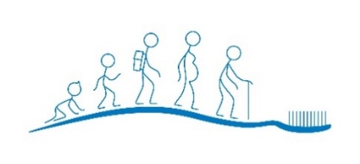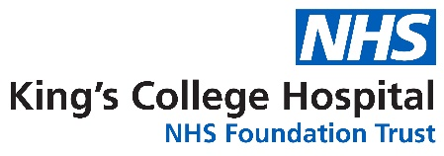***‘Make it Snappy’* Competition**

King’s Oral Health Promotion Team are seeking to capture the creativity of local children living in either Lambeth, Southwark or Lewisham, with a competition to promote looking after teeth in our community. Be as creative as you like!

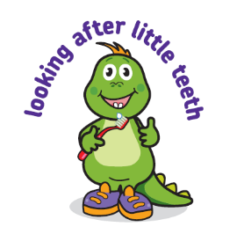**Background information** Children today are still experiencing high levels of tooth decay. Nearly a quarter of all 5 year olds have 3-4 teeth affected, of which the majority are untreated Public Health England (PHE, 2019). The good news is tooth decay is preventable by:

* Twice daily brushing with a fluoride toothpaste
* Spitting and not rinsing your toothpaste out
* Reducing the amount and frequency we eat and drink sugar
* Visiting the dentist

**Prize details**

There will be a winner drawn from each category. They will receive a £10 book voucher as well as a prize for their organisation (£20 worth of science and health themed books).

**Competition details** The competition is open to the following age categories:

* Early years (under 5’s)
* KS1 (5-7 yrs old)
* KS2 (7-11 yrs old)

Entries can include drawings, posters, poems, songs, short stories. Be as imaginative as you like. Your entry must just be themed around looking after teeth.

**How to enter**

Please submit your creation to [cdcfcoffices@gmail.com](mailto:cdcfcoffices@gmail.com)

To enter, you must include:

* Your first name
* Age group
* Title of your work

**Closing date: Friday 6 November (5pm)** Winners will be selected by our Oral Health Promotion team on Tuesday 17 November. You will be contacted by your organisation shortly afterwards.

If you have any further questions, email [cdcfcoffices@gmail.com](mailto:cdcfcoffices@gmail.com)

We hope to display all entries (not just the winners), so be prepared to see your work.

Unfortunately, we are not able to accept late entries.

By entering the competition, you agree that your entry will become the property of King's Oral Health Promotion Team and may feature in future publications.